Model:
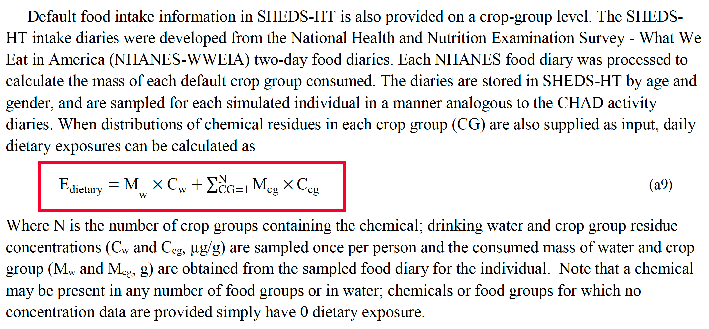
Default food groups:
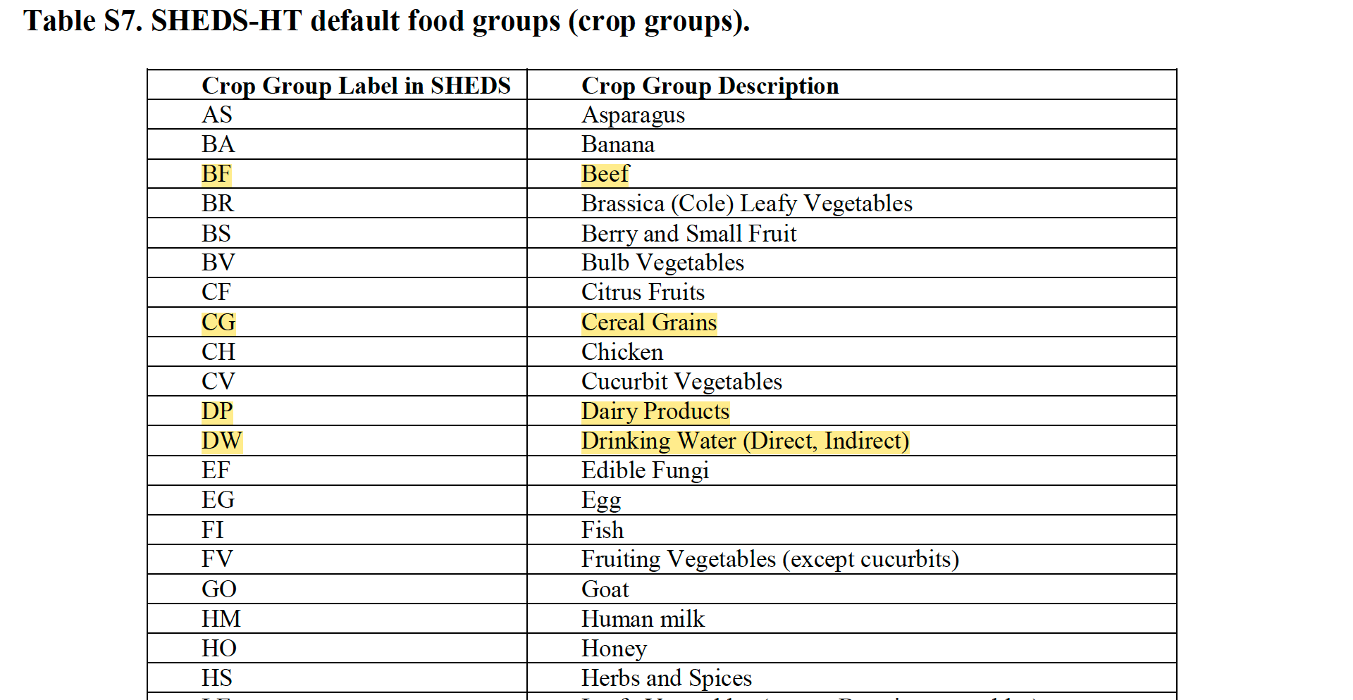
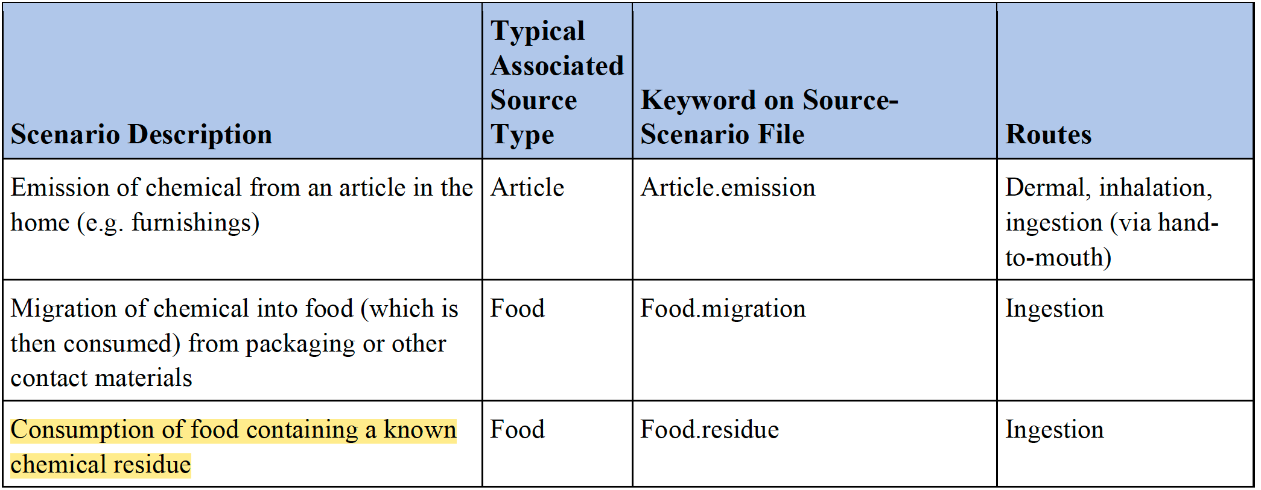
Each of these scenarios has a set of one or more Source- and/or Chemical-specific parameters that must be defined on the Source-Variables and Source-Chemicals input files.
Source- and Chemical-Specific Variables Required by Each Exposure Scenario
Scenario | Parameter Required on Source-Variable File | Parameter Required on Source-Chemical File | Description
Food.residue |  | residue | Concentration in food (ug/g)
 |  | detects | Number of detected residues in data source (can be set to 1 along with nondetects=0 to model nonzero residues for all individuals)
 |  | nondetects | Number of detected residues in data source

SHEDS-HT can handle thousands of chemicals in a single run. Data for these chemicals are spread across input files, so the code must match chemical identifiers from different files. Matching names is very difficult, as some chemicals have common names as well as official IUPAC names, and in many cases there are a variety of written forms for a given name. Another difficulty is the presence of commas in many chemical names, which may be mistaken as field separators, and may not be consistently placed on different files.

Input files are as follows
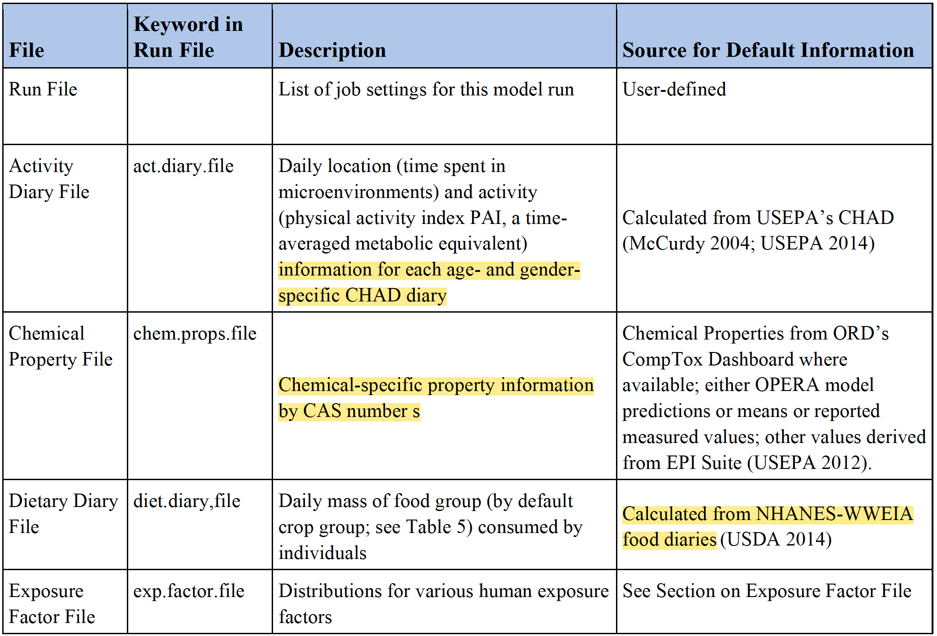
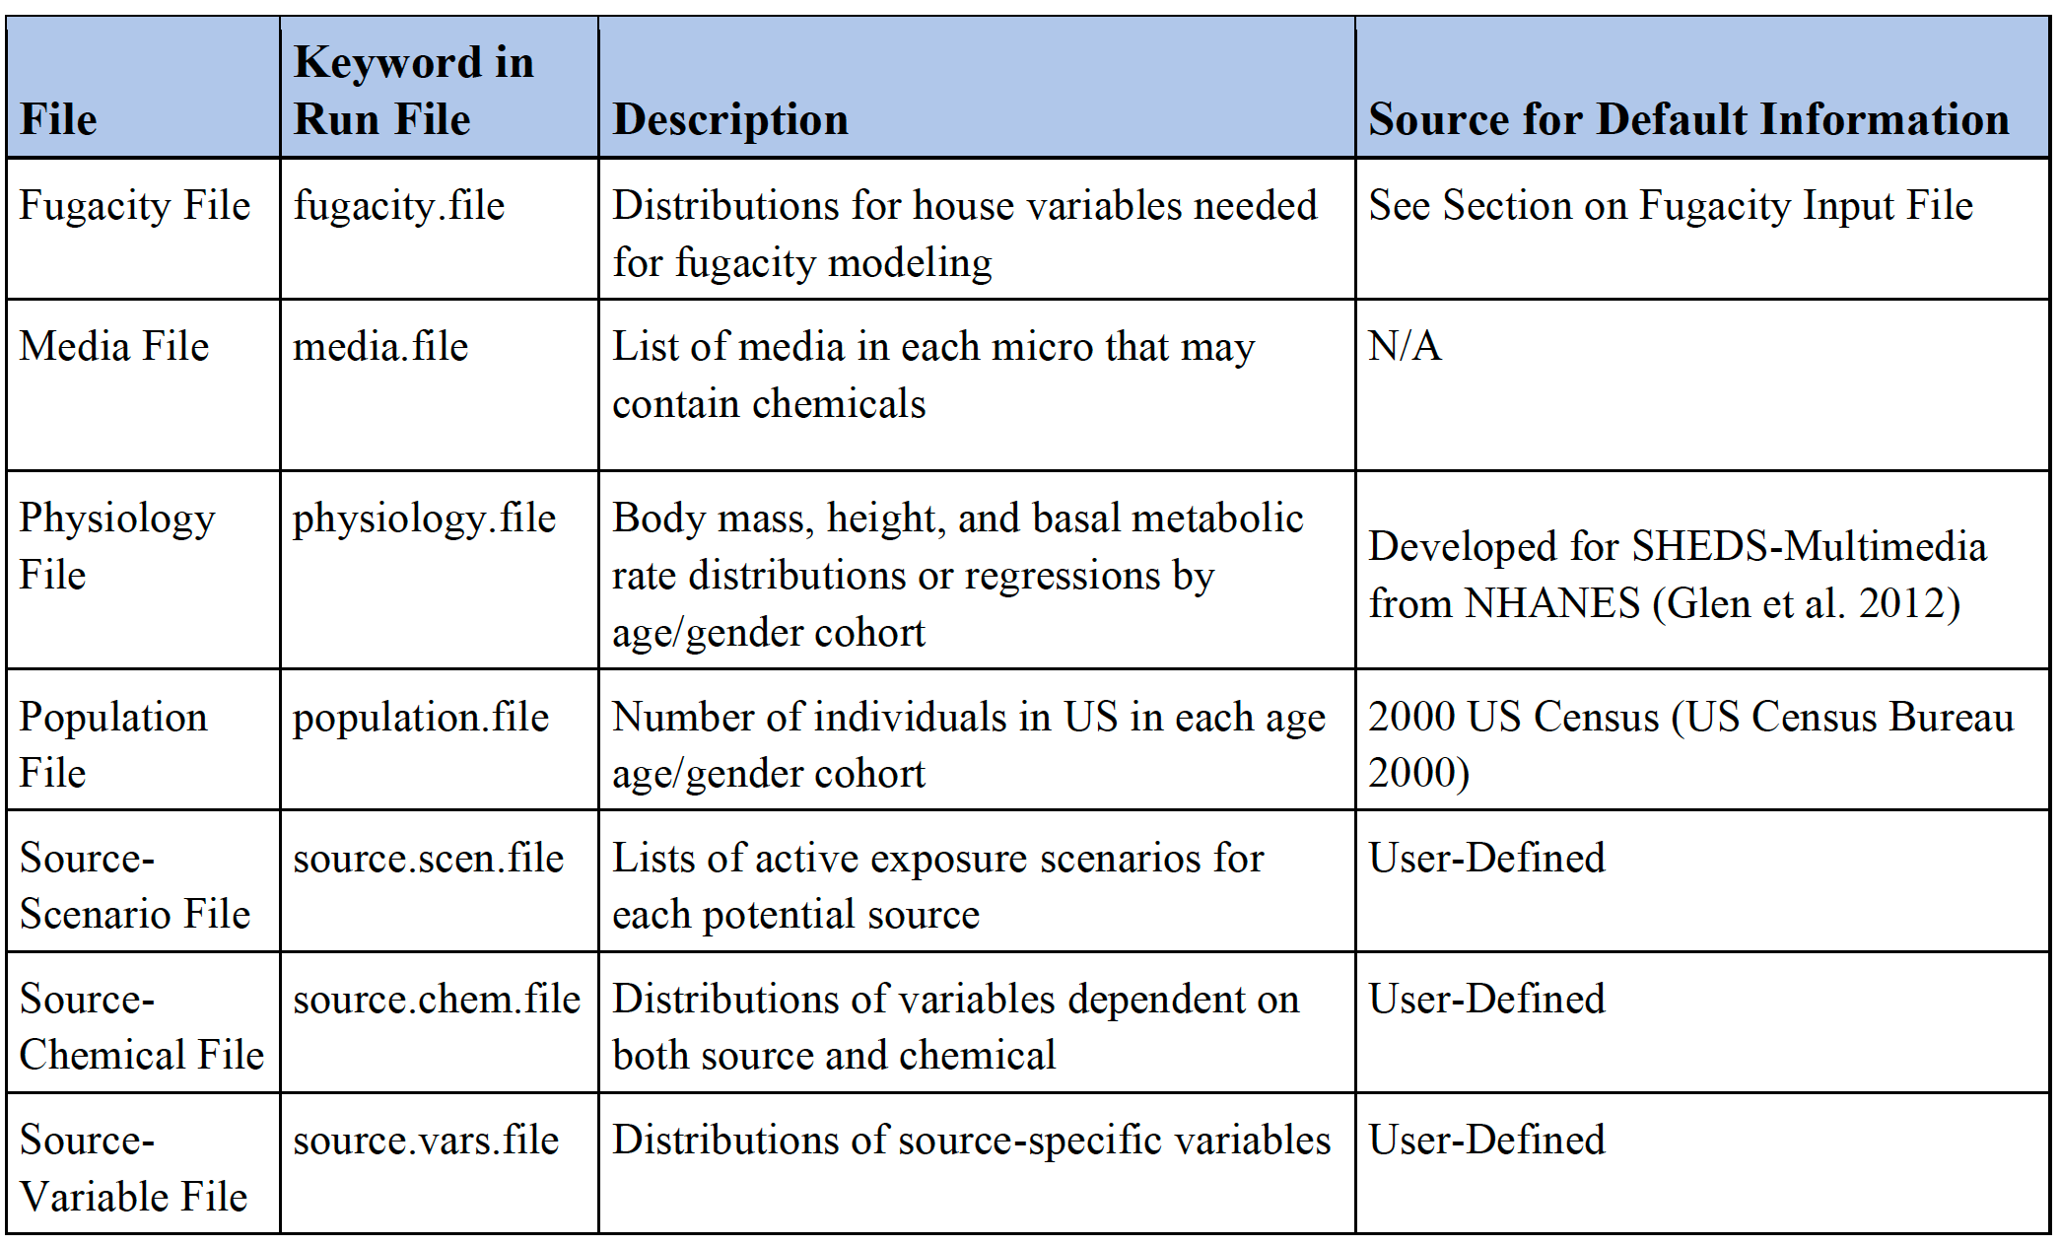
Source-Scenarios Input File
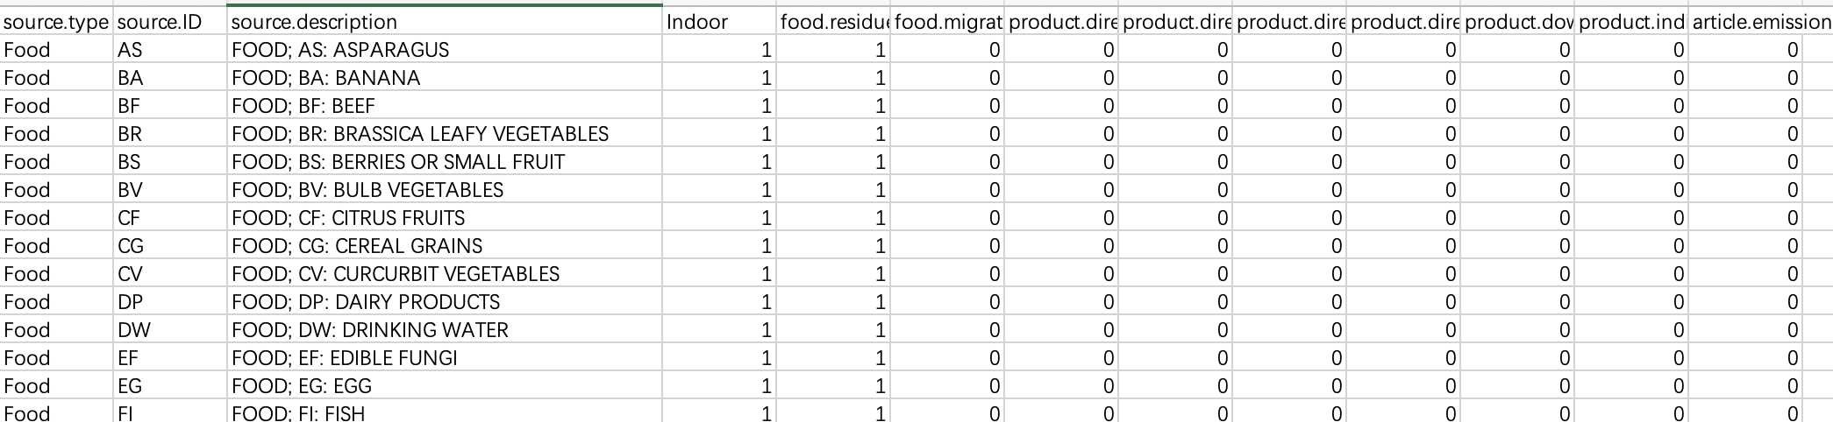
Source-Chemical File
Source-variable file
Based on the SHEDS-HT model, we will get the daily exposure level (ug/day) for a stimulated person based on NHANES and CHAD study data.
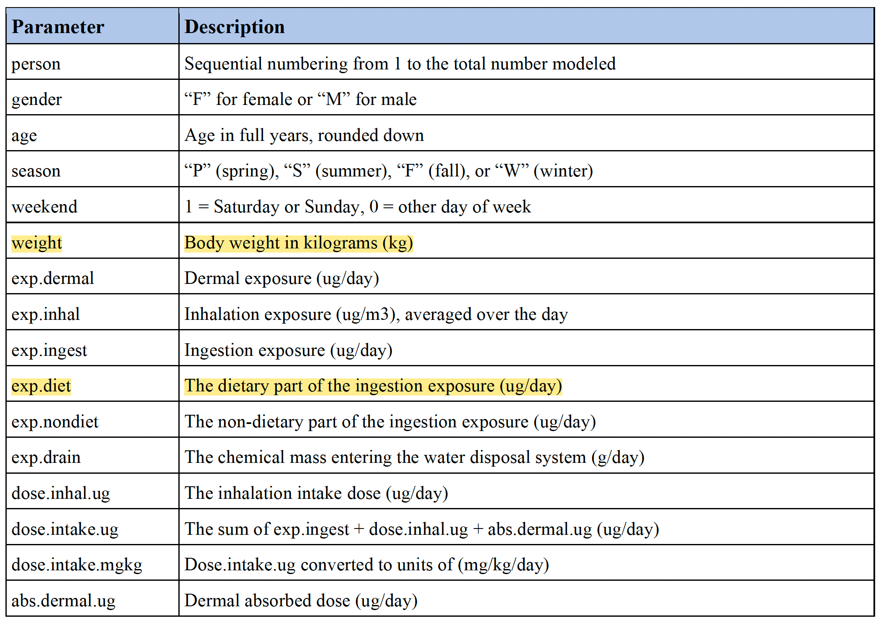

Three kinds of output: all-persons, statistic mean, source mean

